# Setting up evolve on local machine

# Introduction

The following document will permit developers to work on the [e]volve portal on their local machine with the Identity Server installed on their local computer. Here is a quick summary:

* Create a local personal certificate
* Make sure IIS works
* Publish IDS on local machine
* Publish PortalWebService on local machine
* How to run evolve on local machine
* How to trace PortalWebService

## Creating certificates

The software itiverba – Self-Signed Certificate Generator is located on the desktop of the webdev01 machine and in a zip file on SharePoint in the same folder as this file. Copy the application on your desktop.

1. Open the application
2. Click on Edit next to the Subject(CN) text box
3. Fill in the following fields (for the Common Name, give it a name such as your computer name)

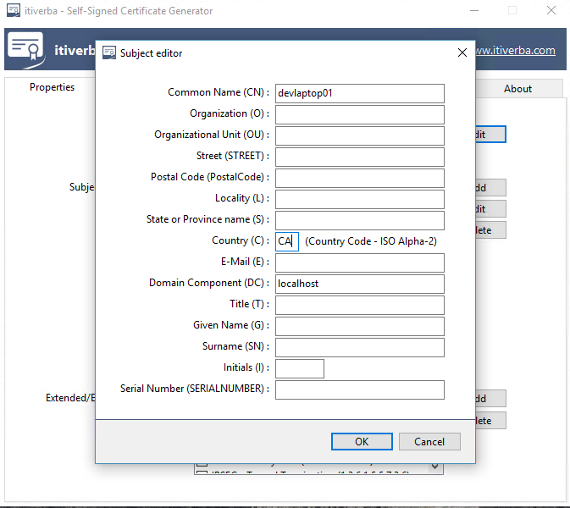

1. Click on Edit button next to the Subject Alternative Name textbox.
2. Fill in the following fields

## 

1. Click on Add button next to the Subject Alternative Name textbox.
2. Fill in the following fields

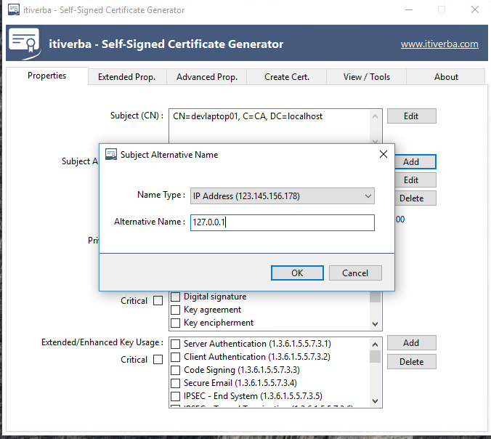

8.Under the Key Usage select the 5 options below

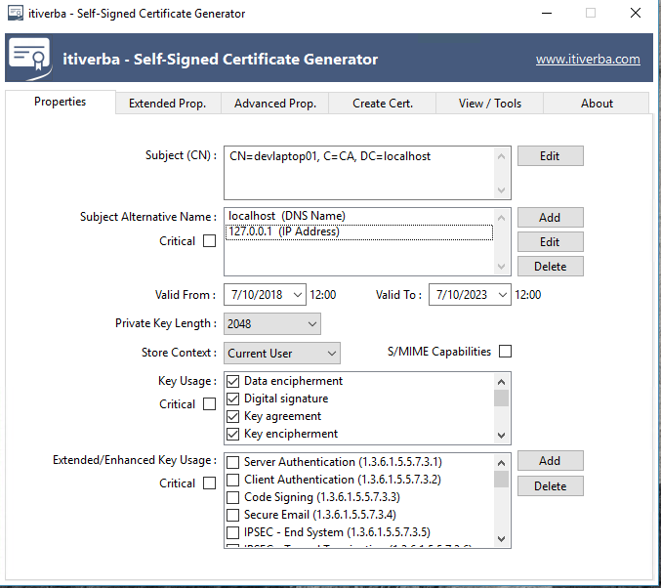

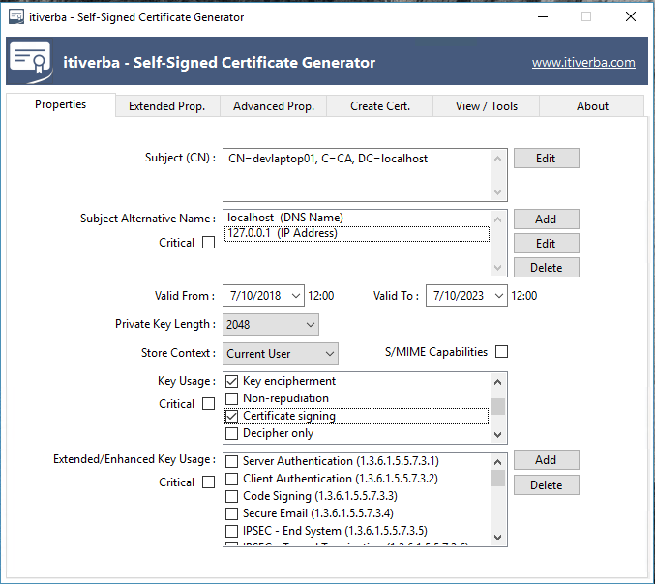

1. Under the Extended/Enhanced Key Usage, select the following 3 options.

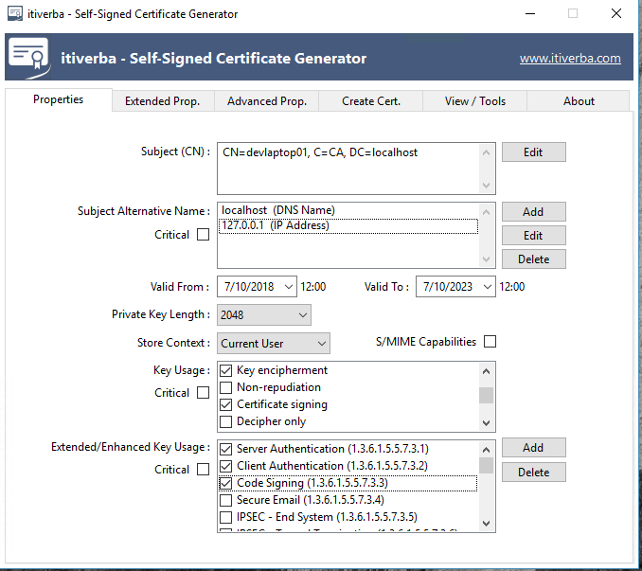

1. Go to the Create Cert. tab
2. Enter a password that you will remember
3. Click on Select File button
4. Navigate to your Desktop
5. Click on Save
6. Click on Create the Certificate

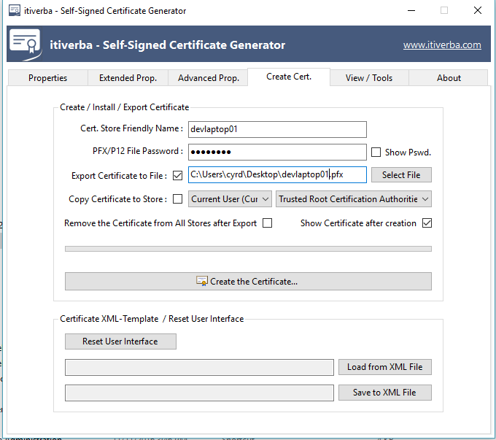

1. Click on Install Certificate…
2. Select Local Machine
3. Click on Next

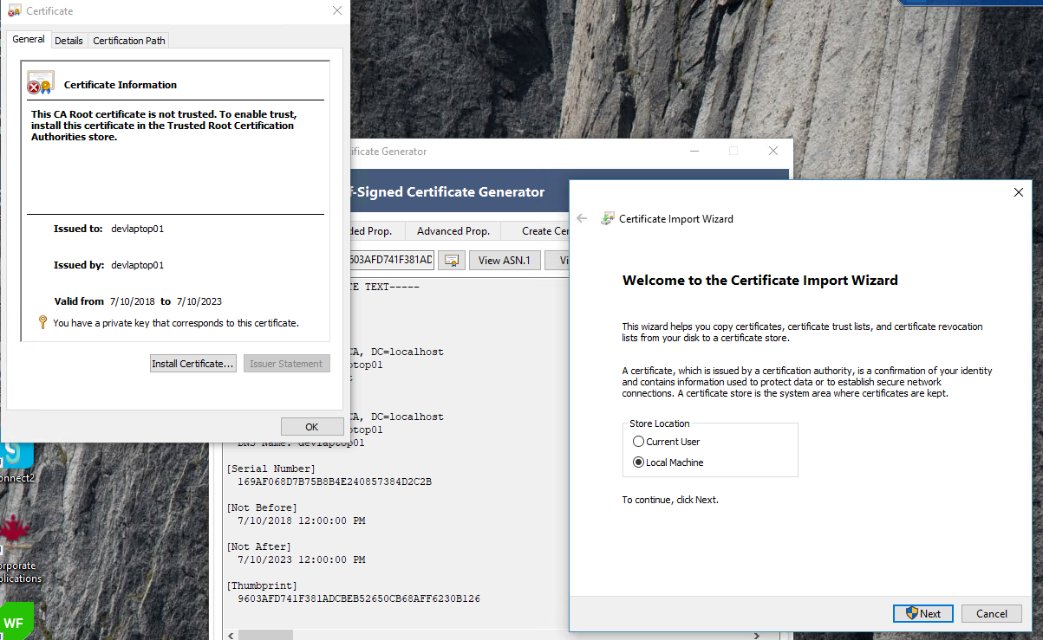

1. Select “Place all certificates in the following store”

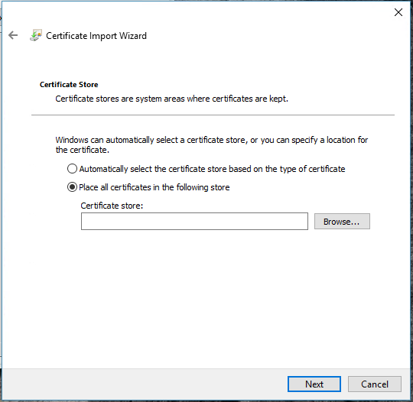

1. Click on Browse
2. Select Trusted Root Certification Authorities
3. Click OK
4. Certificate is done

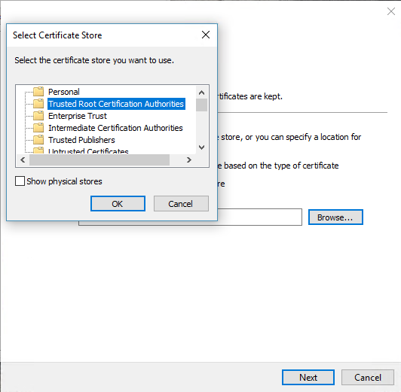

## Installing Local IIS

Make sure local IIS is installed on your computer, IIS Express will not work. To install IIS:

1. Open Control Panel
2. Select Programs and Features icon
3. Click on Turn Windows features on or off

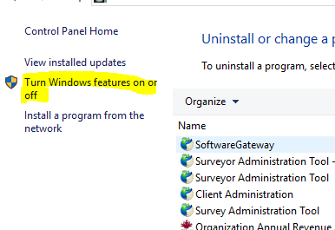

1. Select Internet Information Services
2. Make sure the following options are selected

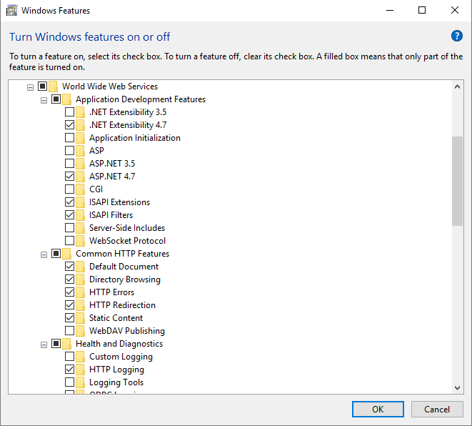

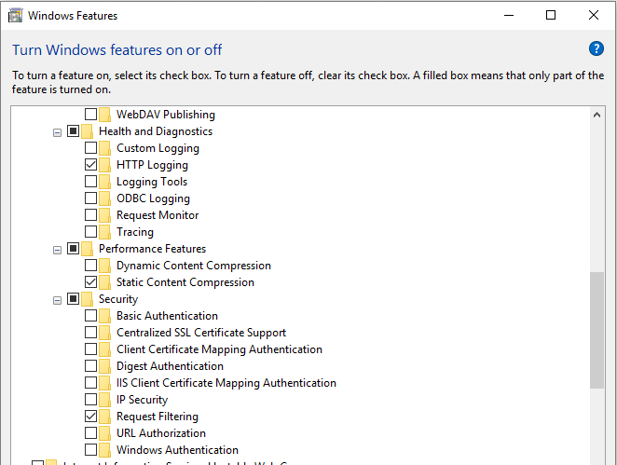

## Publish applications to localhost

You will need to publish both the IdentityServer and PortalWebService application to IIS.

### IdentityServer setup on local machine

1. Get the application from TFS, it is call IdentityServer.
2. Make sure that you have access to clone the project on your local machine.
3. Open the project as Administrator
4. Right click on the HSOIdentityServer project
5. Select Publish
6. If not available create a new profile for localhost
7. Fill in the following information

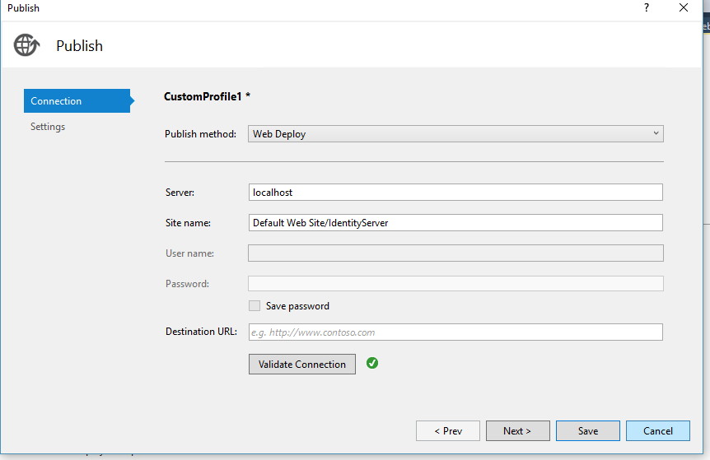

1. Click on Next and make sure that the Configuration is set to Debug

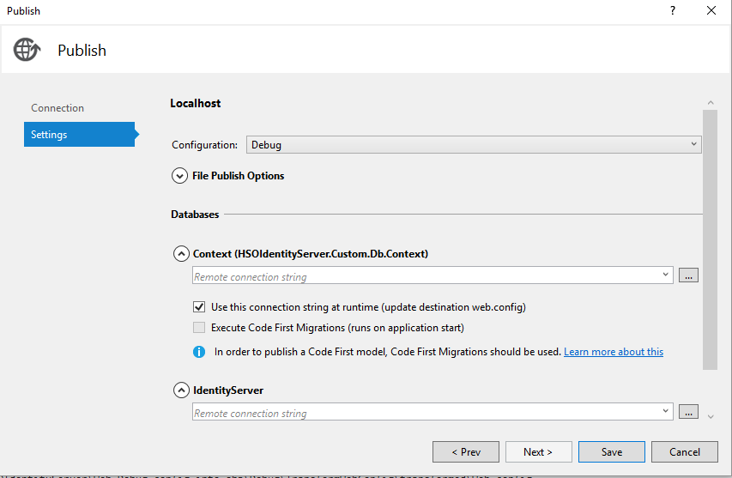

1. Click on Save
2. Click on Publish
3. If you have permission error message go to this link to fix the issue

<https://stackoverflow.com/questions/32648654/web-deployment-task-failed-this-access-control-list-is-not-in-canonical-form-an>

1. Open IIS the IdentityServer project should be under Default Web Site

### PortalWebService setup on local machine

1. Open LPPortal project as Administrator
2. Right click on the project and select Publish
3. If not available create a new profile for localhost
4. Site name should be Default Web Site/PortalWebService
5. Click on next and fill in both database information to be pointing to DBDEV01
6. Click on Save
7. And publish

## Local IIS setup

1. Click on the server name i.e. DEVLAPTOP01 (Domaina\cyrd)
2. Click on Server Certificates icon
3. Get you certificate that you just created by clicking on “Import…” button
4. Enter your password
5. Click on OK

-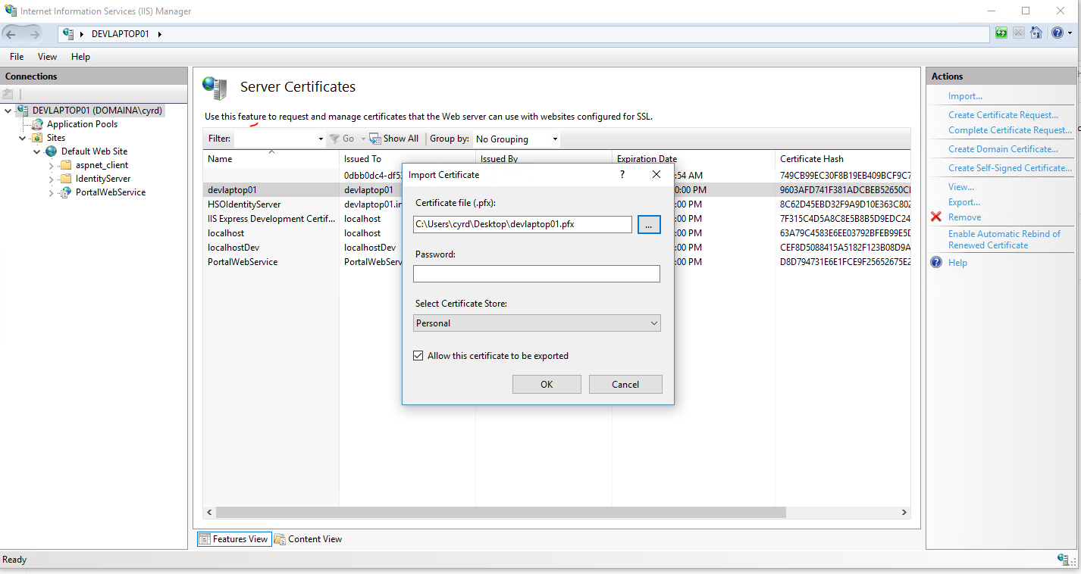

1. Go to Application Pools
2. Add 2 Application Pool one call IDS and another one called PortalWebService
3. Make both Integrated with the latest version of .NET
4. And add the correspondent web sites to the application pools that you just created (go to the Identity Server website, click Advanced Settings, and change its Application Pool to IDS. Then go to PortalWebService and change its Application Pool to PortalWebService).
5. Go to Default Web Site
6. Click on Bindings… link on the right-side panel
7. Click on Add
8. Select Type https:
9. And the SSL certificate that you just added in IIS.

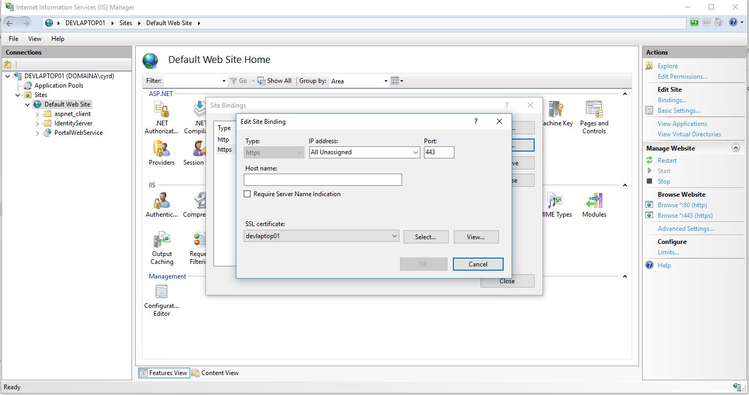

1. Make sure that the word OPTIONS is enters in the OPTIONSVerbHandler for the IdentityServer site:
   1. Select Handler Mappings
   2. Double click on OPTIONSVerbHandler
   3. Click Request Restrictions...
   4. Select Verbs tab
   5. Select One of the following verbs: and enter OPTIONS

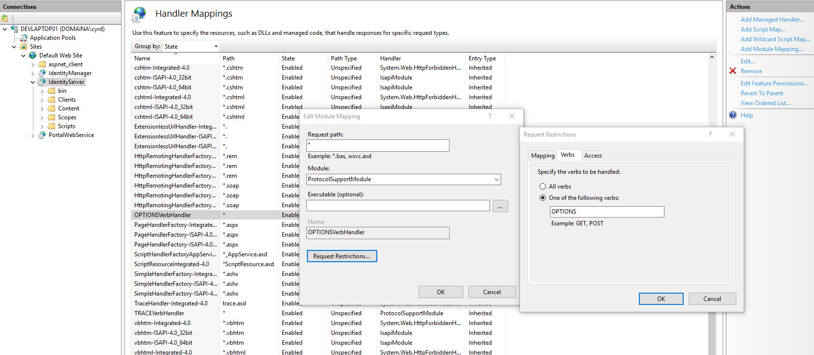

1. Install the “URL Rewrite” IIS extension from <https://www.iis.net/downloads/microsoft/url-rewrite>

## Running the evolve application

1. Open node.js command prompt
2. Enter “ng serve --env=local”
3. Open Chrome
4. URL will be <http://localhost:4200/login/accan>
5. Accan is the licensee code
6. The application should redirect to the IDS link

## Debugging PortalWebService

Because you will need to locally publish the web service each time you update it, the following process will enable you to step through you code.

1. In IIS Browser the web service

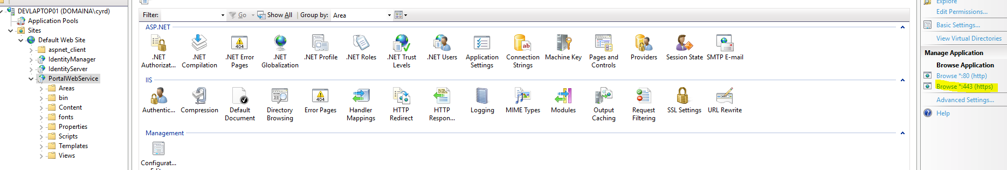

1. In Visual Studio go to Debug 🡪Attached to Process… or Reattached to Process
2. Make sure you select Show processed from all users
3. Search for any services with W3
4. And attach the service PortalWebService

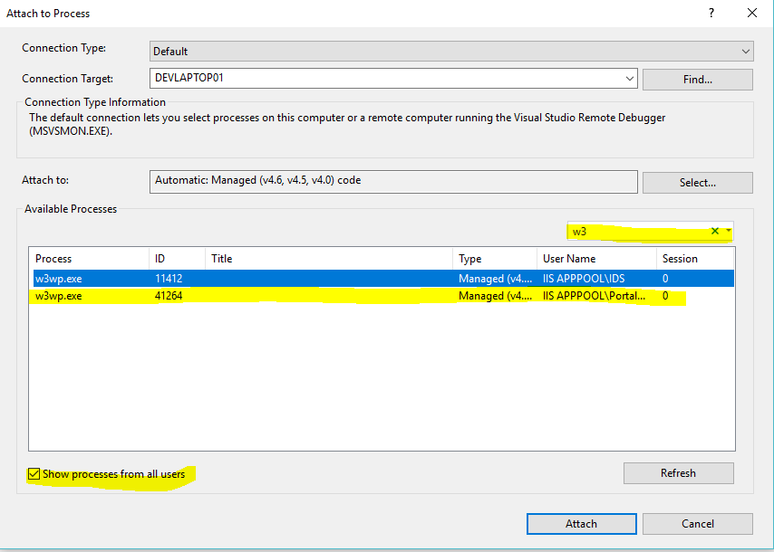

If upon later reopening Visual Studio or changing branches, this process is no longer listed, make sure to open VS using Run As Administrator command, republish the webservice to localhost, and then do these steps again.